Nama: Septian Nanda Saputra

NIM: 1201220007

HOMEWORK

1. Rounded Car

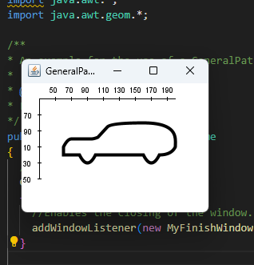

1. Solar System animation

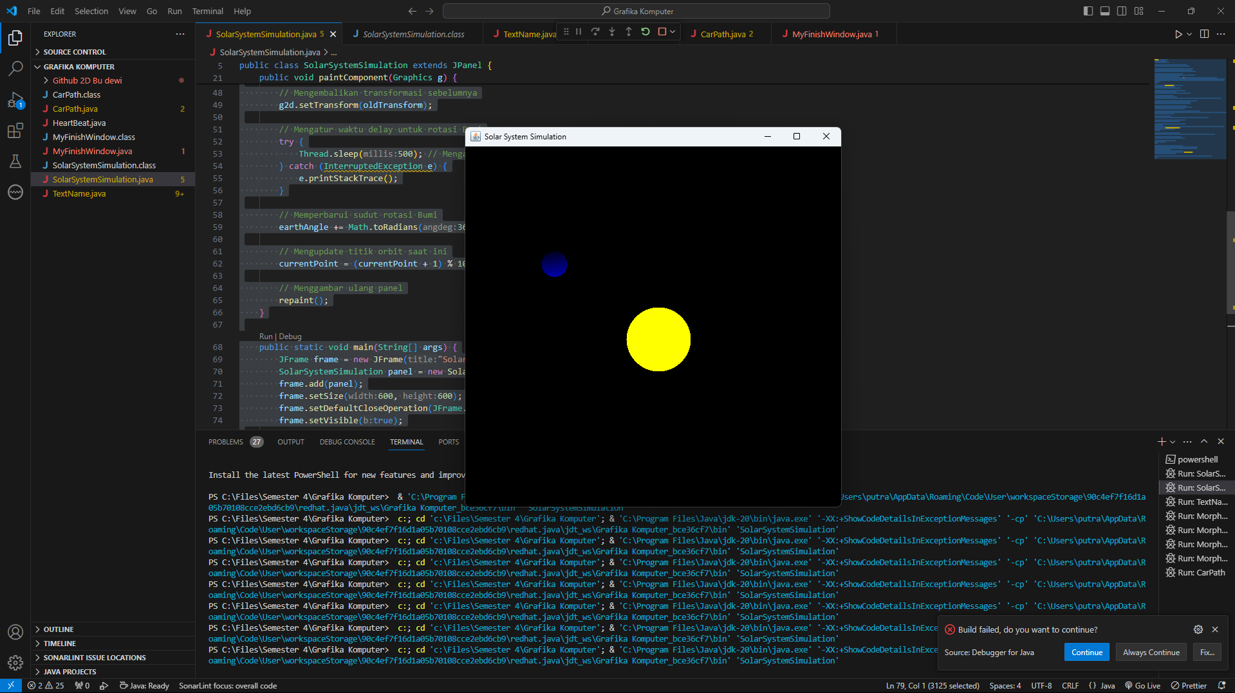

1. Heart Beat

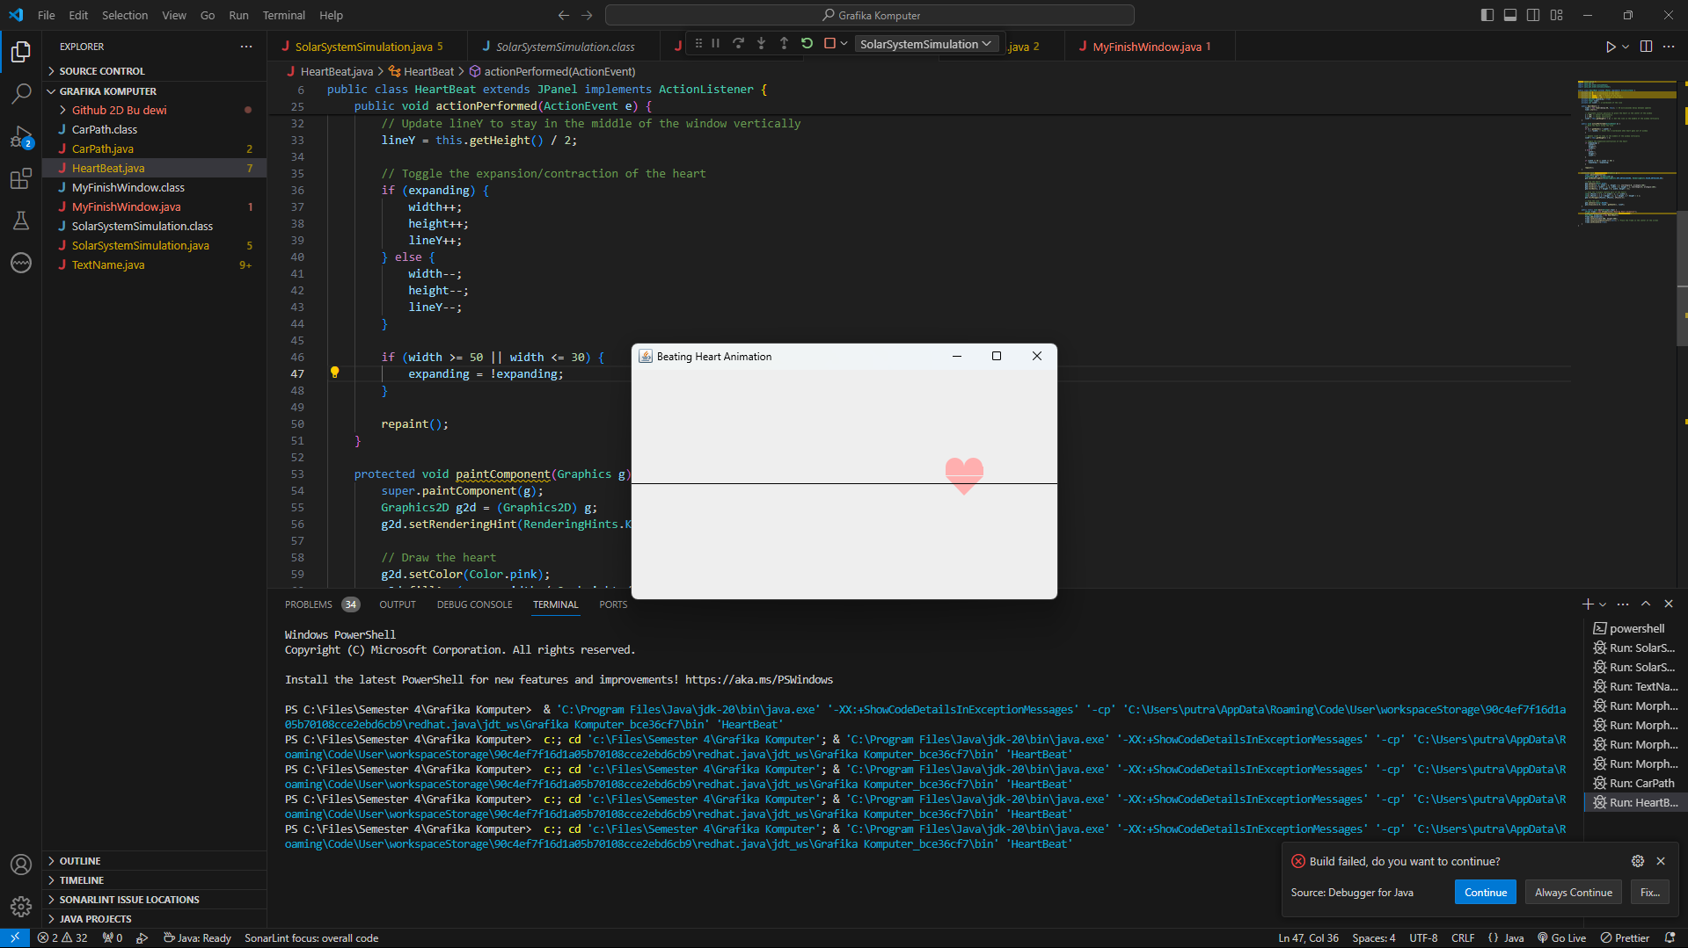

1. Initial Name